**Makorako II: The Makorakoing**

**~~Idiots:~~ Trampers: Jason Rose, Laura Jacks, January 2020**

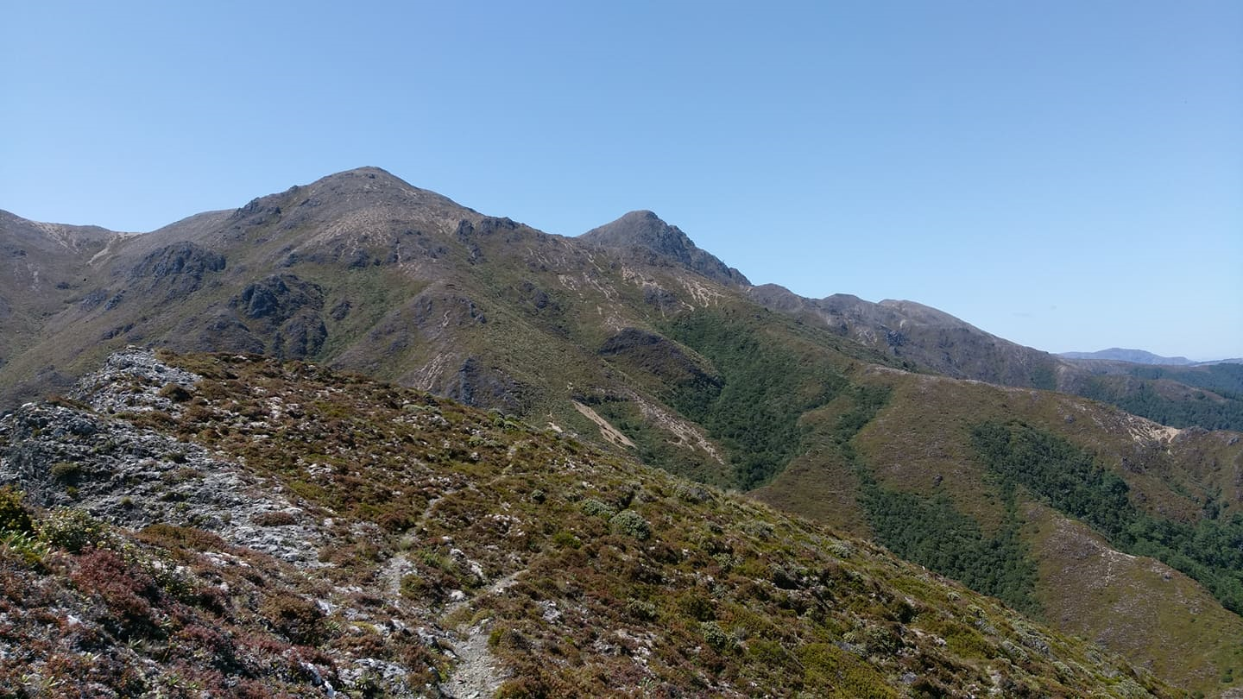

*Makorako and the Island Range*

Few things make you reconsider your life decisions more than sprinting 400m up a mountain half naked, straight out of bed, after getting 4 hrs of sleep - because all your food is gone. Why, you ask? I blame Toby, he lent us his car. Without him, this wouldn’t have been possible. I blame Laura. She’s an extremely supportive partner and frankly her enabling has gone too far. But TBH, I blame me the most for having the stupid idea of going to Makorako in the first place. Honorable mention: Helisika’s private block

It all started seven months ago when I was just minding my own business climbing on the Tukino side of Ruapehu, and I happened to notice a rather gorgeous pointy fella in the direction of the Kaimanawa. It was a beautiful, isolated pyramid, covered in snow and standing proud above all of the other mountains I could see. I later found out that it was a 1727m peak called Makorako, the sixth highest mountain in the North Island, and by all accounts an utter pain in the ass to get to. Naturally, I tried to work out if it could be done in a weekend. The plan would be to walk into Waipakihi hut on Friday night, after driving from Auckland. It’s a reasonable tramp, 14km and 1100m+ elevation gain, ~4hrs at a steady pace.

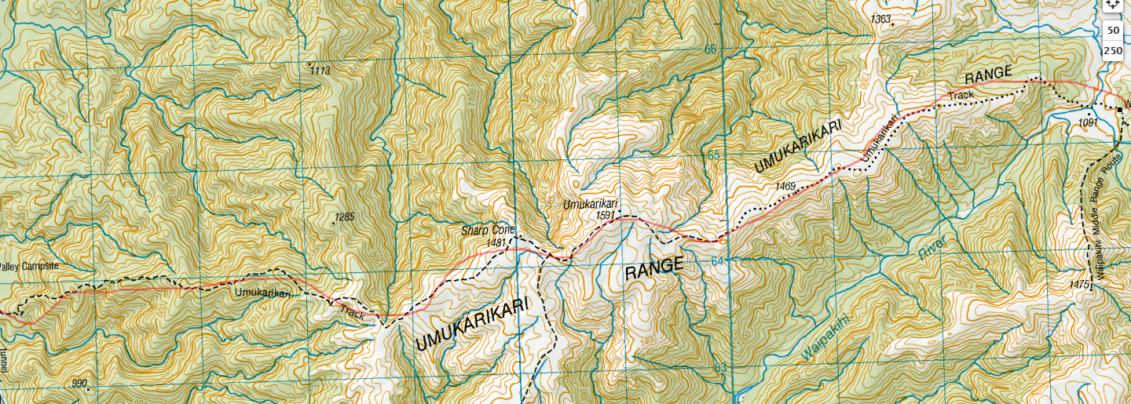

*“I’m going to go to spookers instead” - Max Jenkins*

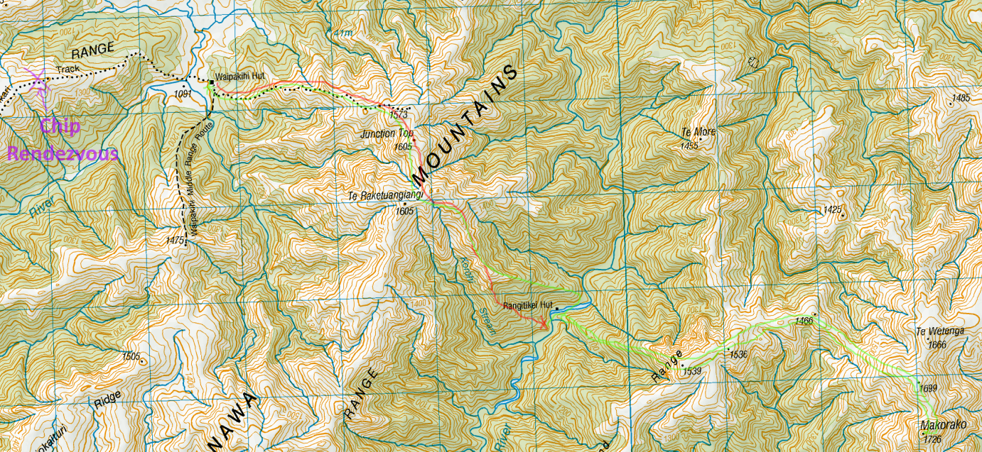

*“Have you done intentions?” - Max Jenkins*

Following this, we would climb Junction Top, bushbash down into the Rangitikei, bushbash up out of the Rangitikei to the Island Range, then gap it to Makorako and return the same way to Waipakihi hut, where we would presumably drop dead on the floor, having OD’d on chips, bush lawyer and contours. Then we’d walk out and drive back to Auckland the following day. Solid plan, right?

***WRONG.***

Like most plans, it’s bloody made up. After successfully walking into Waipakihi at 2AM, 4 hrs after leaving the carpark and 10hrs after leaving Auckland, we passed out in our tent in front of the hut, so as not to wake people up. Like a good ex-gear officer, I left my food (8 packets of chips in a tupperware in a drybag) in the hut so rats wouldn’t eat our shiny club tent. Given our late bedtime, we resolved to be up by the ungodly hour of 9AM, in preparation for our minimum 12hr day the next day. I woke up naturally sometime around 8, overheard some talk about chips (*ominous foreshadowing*) and continued sleeping until 9, when our alarm went off. When I walked into the kitchen for breakfast, I was quite alarmed to discover that all of my beloved chips were gone, my rations for the next 2+ days. After politely interrogating the people still at the hut, I found out that some ~~dirty thieves~~ community spirited people, that left an hour ago back along the Umukarikari track, thought that it was trash left at the hut and had resolved to carry it out, tupperware and all. After a lot of $#&#!@ing, I ran half naked with an empty drybag in my hand like some sad santa, back up Umukarikari in the hot sun. They had at least a 45min head start on me, so I knew I had my work cut out.

Luckily for me, I’ve made a habit of being late for labs and having to sprint up hills to get to get to them. After ~20mins and ~400m, looking and dripping like a naked mole rat in a sauna, I caught the chip thieves. Clearly intimidated by this power move, they profusely apologized and handed me my lunchbox (yay!) and, unfortunately, only 6 packets of chips (pooooo). The trip was potentially still on, but I’d added 400m of elevation and 4km to my already long day in the hot sun. Jogging back my hamstrings started to cramp up and I decided to walk, deciding that Makorako today was now probably unrealistic. After a big breakfast, a lot of water, even more foam-rolling and an obligatory tasteful ~~nude~~ photoshoot (~~DM me 😘~~) we set off at 12 up to Junction Top.

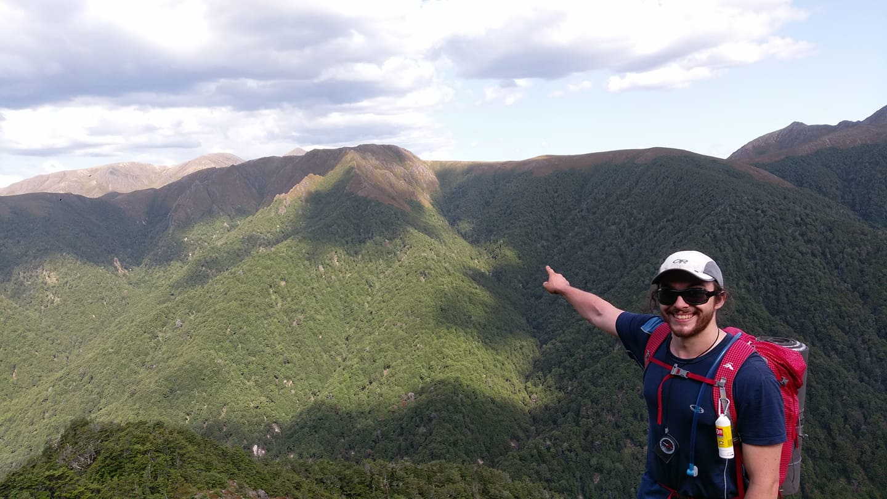

*The ridge we’d have to bushbash 500m up, with Makorako poking just above*

An hour and a bit later, we arrived at the top and began searching for suitable looking ridges to get in and out of the Rangitikei. We decided on a rather spiky looking one, because it looked fun and was the closest. The bush down to the Rangitikei however was rather stimulating. Humongous hedges of bush lawyer atop rotten logs, perched perilously above clay cliffs, conspiring to force you off the ridge into gullies where their similarly spiky comrades awaited eagerly in ambush.

Four glorious hours after entering the bushline, we’d managed to descend the required 300m to the river. We decided to make dinner and camp there after having a peek at Rangitikei Hut, ~~seeing that it was covered in deer poop~~, and resolving to respect their private property rights. Access is a privilege, folks.

After starting walking again at the ungodly hour of 9AM in preparation of our 12hr+ day, we charged up the ridge to the Island Range. Somehow, although I suspect it was all of the cliffs we climbed up, as well as being unburnened with all of the excess skin, clothes and sleeping mat lost the previous day, it only took us 1.5hrs to bushbash to the bushline.

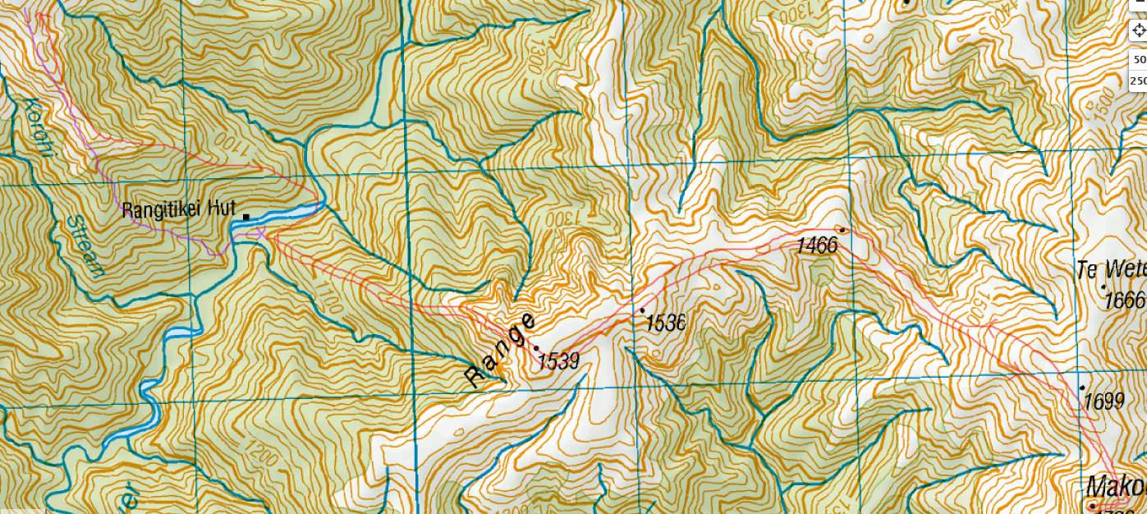

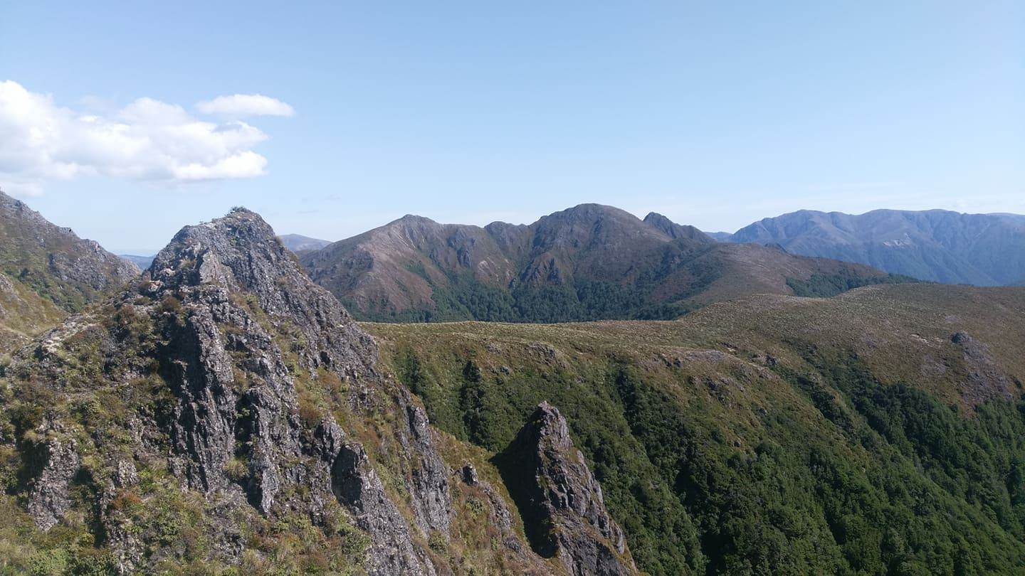

*The ridge we climbed up made for some enjoyable scrambling*

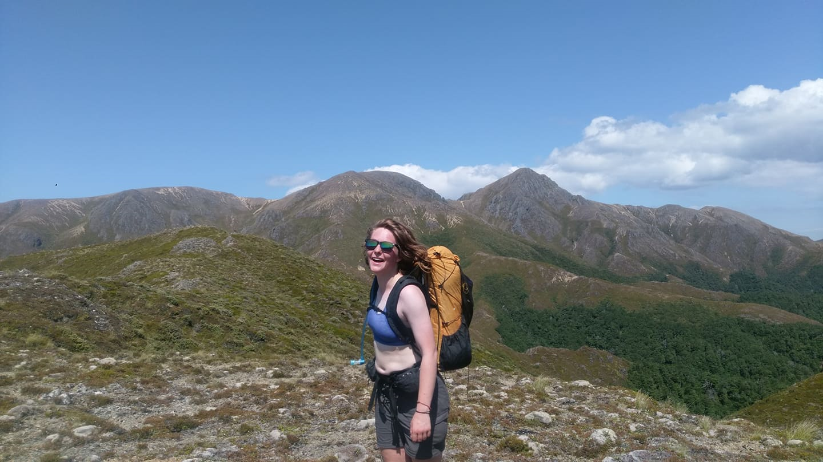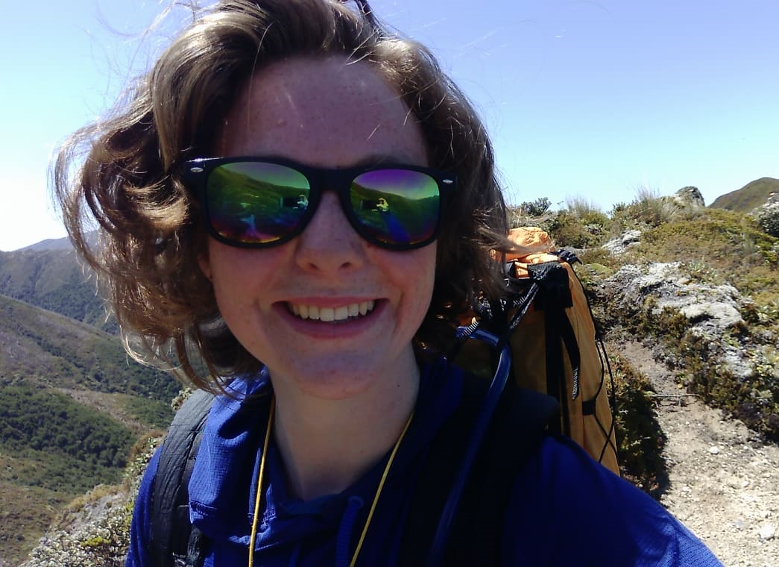

*Makorako and the Island Range, ft. a massive cutie*

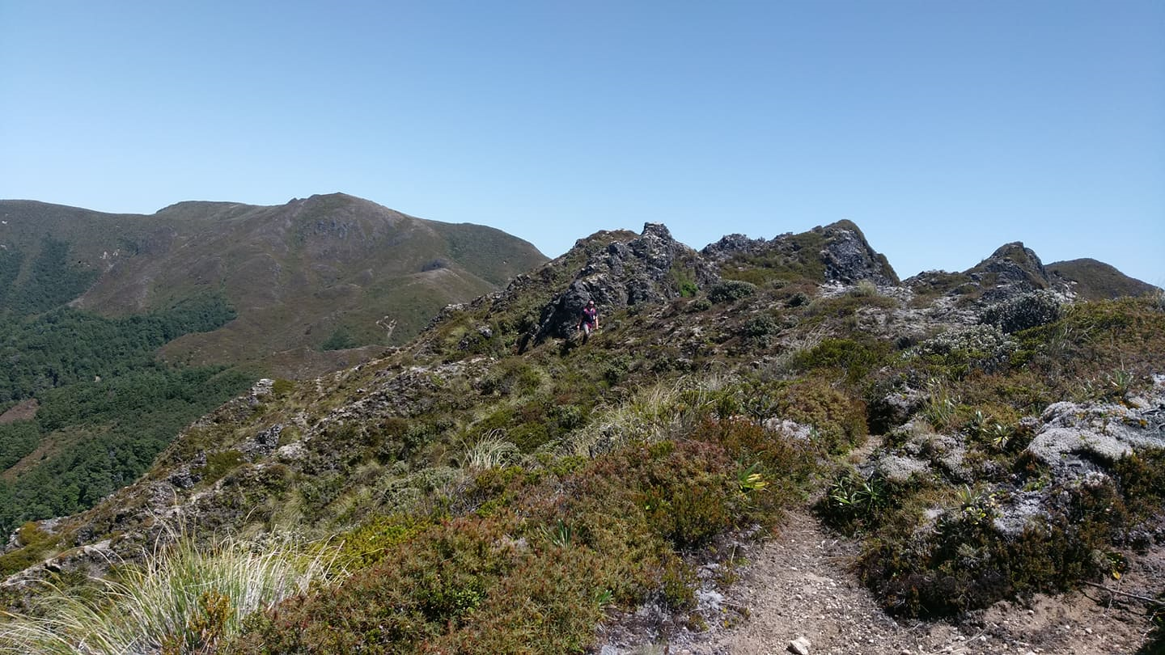

*On the saddle along the Island Range, looking back to where we climbed onto it*

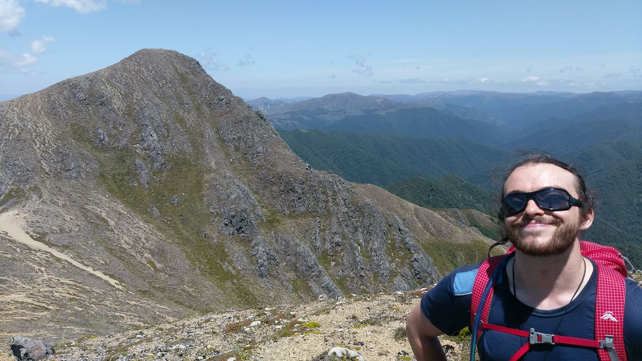

*Me, chuffed, ft. Makorako*

After a bit over an hour groveling in the blistering heat along the ridge, we’d made it. Makorako. HALF WAY, BABY! Naturally, much faffing and all sorts of shenanigans occurred on the summit and we dedicated a rock to our dear friend Toby, without whomst our suffering would not have been possible.

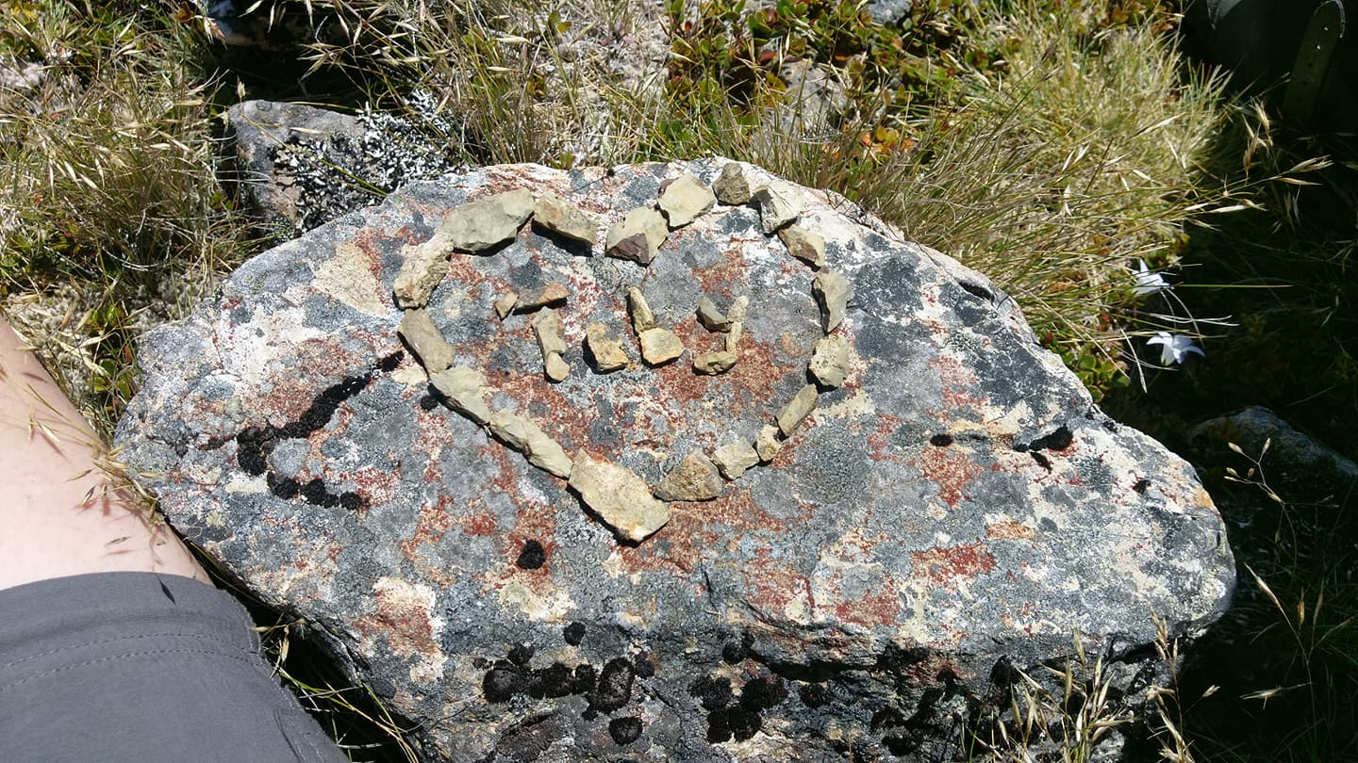

*We <3 you Toby, ft. Phred, the highest tussock in the Kaimanawa*

Realizing we’d run out of water, we began our march back down to the Rangitikei. Unfortunately, something which was a recurring theme of this trip, our downs ended up having a lot of up. There was a large pringle in between the ridge we’d ascended and Makorako, quite a few of them actually. After some more groveling in the midday heat for an hour, we arrived at the bushline. We charged down the ridge with fearsome yet invigorating velocity, the many cliffs clearly sensing our dire need for moisture and offering their full support. A couple of hours later, we were swimming in the lovely, cool Rangitikei. Very aware that we had a challenging bushcrash back up to Junction Top ahead of us, we continued faffing and had some noodles. They were alright.

For the second time this trip, we set off up a hill at 8:30PM. We’d decided to take a different ridge up to Junction Top, because the last one had proven a little bit too clingy and we needed space. Laura took point, navigating by hand torch we’d picked up from the Tūrangi New World for an extortionate $15 on the way down. This proved to be a good decision, because moths and flies had nothing better to do than lodge themselves by the hundred in all of your facial orifices simultaneously the moment you turned on your head torch. I am rarely one to turn down free protein, but I considered the expense of all the counselling and therapy I would require afterwards and concluded it was out of my budget. After much groveling, scrambling and impenetrable birch thickets, we finally arrived at the ridge to Junction Top after 5 hrs.

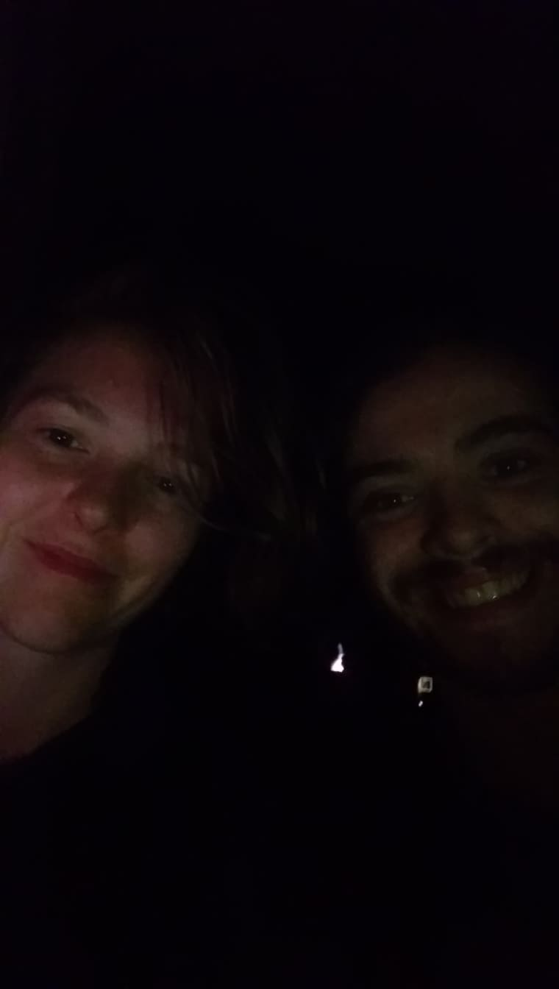

We frantically emailed Helisika to let them know that we were clear of their land. We messaged our friends to let them know the happs, then charged off to Junction Top and Waipakihi hut, a thrilling headwind taking the spring out of our step on our midnight stroll. We arrived at the hut at 3AM, after 18hrs on the go, and passed out on the floor, having OD’d on chips, bush lawyer and contours.

The next day we woke up at 11AM, in a surprisingly small amount of pain. After breakfast, much faffing and manic laughter, we left Waipakihi at 1PM and charged up Umukarikari for the second time this trip. Our feet were a little annoyed at us, and we got to the car in 3 hrs something, having ran a reasonable chunk of the track from the bushline to the car. This entire time we were worried: would the bottle of first cold pressed extra virgin olive oil that we’d left under the car still be there? Fortunately, it was, and we feasted on the finest of caprese salad and pasta in Tūrangi and Taupō on the drive.